**ASSIGNMENT COVER SHEET**

|  |  |  |  |  |
| --- | --- | --- | --- | --- |
| PROGRAMME | : | Masters in Business Analytics | | |
| SUBJECT CODE AND TITLE | : | BAA5113 - Web and Social Media Analytics | | |
| ASSIGNMENT TITLE | : | Web and Social Media Analysis Towards Recommendations  For Improving Business | | |
| WORD COUNT | : | 6362 words | | |
| LECTURER | : | Dr. Aaron Aw Teik Hong | ASSIGNMENT DUE DATE: | 14th of June 2024 |

STUDENT’S DECLARATION

1. I hereby declare that this assignment is based on my own work except where acknowledgement of sources is made.
2. I also declare that this work has not been previously submitted or concurrently submitted for any other courses in Sunway University/College or other institutions.

[ Submit “Turn-it-in” report (please tick √): Yes __√__ No _____]

|  |  |  |  |  |
| --- | --- | --- | --- | --- |
| NO. | NAME | STUDENT ID NO. | SIGNATURE | DATE |
| 1. | Abdul Hakim Bin Kamalur Rahman | 24015257 | HAKIM | 14th of June 2024 |
| 2. | Chau Keen Zhi | 24013732 | KENJI | 14th of June 2024 |
| 3. | Harresh Ragunathan | 19076090 | HARRESH | 14th of June 2024 |

E-mail Address / Addresses (according to the order of names above):

|  |  |
| --- | --- |
| 1. 24015257@imail.sunway.edu.my | 4. |
| 2. 24013732@imail.sunway.edu.my | 5. |
| 3. 19076090@imail.sunway.edu.my | 6. |

APPROVAL FOR LATE SUBMISSION OF ASSIGNMENT (If applicable)

IF extension is granted, what is the revised due date? ______________________________________________

Signature of Lecturer: ______________________________________ Date: ____________________________

|  |
| --- |
| Marker’s Comments: |

Marks and / or Grade Awarded: _____________________________ Date:__________________________

**ADDENDUM**

**USE OF ARTIFICAL INTELLIGENCE (A.I.) DECLARATION**

Students are allowed to use AI to support completion of assessments. However, students are reminded to do so ethically and transparently. This is so that (a) submissions can be fairly and accurately marked; and (b) feedback can be provided on the content that reflects student ability, in order to help with future submissions. Students are also reminded that in accordance with the University’s Academic Malpractice Policy, Item 4.11.2, “*… the representation of work: written, visual, practical or otherwise, of any other person, including another student or* ***anonymous web-based material*** *[emphasis added], or any institution, as the candidate’s own*” is considered malpractice.

**Declaration**

[ √ ] I / We used the following A.I. tools to produce content in this submission:

|  |  |  |  |
| --- | --- | --- | --- |
| **Tool** | **Purpose** | **Prompts** | **Sections where AI output was used / Outcome(s) in the submission** |
| *ChatGPT* | * *Used to brainstorm ideas during preliminary stages of the assignment – eg. what specific aspects of the topic can we explore?, assistance with the formulation of the research question and research objectives* |  | *N/A* |

*Note: Add additional rows if necessary.*

**OR**

[ ] I / We did not use any A.I. tools to produce any of the content in this submission.

|  |  |  |  |  |
| --- | --- | --- | --- | --- |
| NO. | NAME | STUDENT ID NO. | SIGNATURE | DATE |
| 1. |  |  |  |  |
| 2. |  |  |  |  |
| 3. |  |  |  |  |

E-mail Address / Addresses (according to the order of names above):

|  |  |
| --- | --- |
| 1. | 4. |
| 2. | 5. |
| 3. | 6. |

**Table of Contents**

**Introduction** **2**

**Web Analytics Landscape** **2**

Web Metrics Comparison 2

Search Engine Optimization and Visibility 5

Interactivity and User Engagement 9

Mobile Optimization 12

**Data Preparation** **16**

**Sentiment Analysis** **18**

**Data Visualization** **20**

**Social Network Analysis** **25**

**Discussion** **34**

Themes Identification & Demographic Insight 34

Sentiment Connotation 35

Social Network Analysis 36

**Future Recommendations** **37**

**Conclusion** **39**

**References** **40**

**Appendix** **41**

# Introduction

Best Buy Co., Inc. is one of the leading multinational consumer retailers that specializes in electronic appliances, computers, mobile phones, and many other electronic related products. Furthermore, they also provide services such as technical support, consultation, and delivery and installation services. The main target consumers of Best Buy are consumers who are looking for or interested in purchasing electronics for various purposes depending on their needs. As one of the leading companies in the electronics retail industry, Best Buy has 1,051 retail stores located in the United States. Additionally, Best Buy also engages in eCommerce by running a website that allows users in the United State and Canada to purchase products online. With the retail industry rapidly transitioning to eCommerce platforms, businesses are required to allocate more resources and time into improving their online presence to improve their brand awareness, online presence, and user experience, which in turn, improves sales. For Best Buy to achieve these goals, they must utilize various web analytics tools to identify their strengths and weaknesses, in the form of statistics, regarding the user experience when using their websites.

# Web Analytics Landscape

## Web Metrics Comparison

Web metrics are indicators used to determine the performance of a website. In this study, the metrics included are Performance Score, First Contentful Paint (FCP), Speed Index, Time to Interactive (TTI), Bounce Rate, and Session Duration. These web metrics were retrieved by using Google Lighthouse (Python) and SimilarWeb. Although it is sufficient to retrieve the web metrics only for Best Buy, in this study, the web metrics were also retrieved for its competitor, which is Walmart. By comparing the metrics with Walmart, Best Buy may use their indicators as a benchmark, which will provide a clearer understanding relative to the electronics retail industry.

In this study, the metrics mentioned earlier, excluding Bounce Rate and Session Duration, were retrieved using Google Lighthouse with the use of Python in Google Colab, and the use of Google Cloud Console and Google PageSpeed Insights API. Using Python in Google Colab, the necessary libraries must first be installed, in this case ‘requests’, which allows Python to make HTTP requests. Following this, the API key and URL is set up, along with indicating ‘desktop’ or ‘mobile’, which enables the extraction of the performance metrics to be made from Lighthouse.

To retrieve the Bounce Rate and Session Duration, SimilarWeb, a website that measures website traffic, was used. The table below contains the web metrics retrieved from Google Lighthouse and SimilarWeb for both Best Buy and Walmart, specifically their desktop metrics.

**Table 1 - Web Metrics (Desktop)**

|  |  |  |
| --- | --- | --- |
| **Web Metrics** | **Best Buy** | **Walmart** |
| Performance Score | 57.99 | 38.0 |
| First Contentful Paint | 0.8s | 0.9s |
| Speed Index | 4.5s | 7.2s |
| Time to Interactive | 8.5s | 12.8s |
| Bounce Rate | 45.4% | 52.21% |
| Session Duration (mm:ss) | 03:57 | 04:44 |

At initial glance, it may be observed that Best Buy has a performance score of 57.99, which is higher than Walmart’s performance score of 38. According to Lighthouse, the performance score is based on their calculator which has a weighted average based on the other metrics scores, meaning certain metrics have been weighted to affect the performance score based on significance (Google, n.d.-a). From these performance scores, it is evident that Best Buy’s website performs better overall compared to Walmart’s.

First contentful paint (FCP), is a metric that measures how long it takes for the page’s content to render after a user has initially navigated to the page (Google, 2023-a). Ideally, it is important to have quick load times as it is likely to retain the consumer’s attention better. From the table above, it may be observed that Best Buy has an FCP measure of 0.8s, which is faster than Walmart’s FCP of 0.9s, by a 0.1s margin. This implies that the time it takes for both Best Buy’s and Walmart’s website to load the content after a user navigates to its page is relatively quick.

Speed index is a metric that measures how quickly content is visually displayed during page load (Google, n.d.-b). Ideally, a lower time indicates that the content is displayed faster. Looking at the table above, Best Buy’s speed index is 4.5s, while Walmart’s speed index is 7.2s, indicating that Best Buy’s content appears faster than Walmart’s. However, according to Lighthouse, Best Buy’s speed index falls in the range of moderate speed, meaning that Best Buy has some room for improvement.

Time to interactive (TTI) is a metric that measures the time it takes for a page to become fully interactive, meaning it can respond to user input at a fast rate (Google, 2023-b). Generally speaking, a lower time within the 0 to 3.8s range is ideal. Observing Table 1, Best Buy has a TTI of 8.5s while Walmart has a TTI of 12.8s, indicating that Best Buy’s page becomes fully interactive faster. However, according to Lighthouse, Best Buy’s TTI falls under the slow range, meaning that Best Buy’s TTI indicates poor performance.

Bounce rate is a metric that measures the percentage of consumers that visit their website and leave after viewing one page (Adobe, 2023). Ideally, a lower percentage is favorable as it indicates that more consumers are viewing more than one page (not leaving the website early). Observing the table above, Best Buy has a bounce rate of 45.4% while Walmart has a bounce rate of 52.21%, indicating that less consumers leave Best Buy’s website after viewing one page, compared to Walmart’s website. Best Buy’s bounce rate is in a good spot, however there is some room for improvement, as the ideal range is 20% to 45%.

Lastly, session duration is a metric that measures the average time that consumers spend on their website per visit. Ideally, a higher time is favorable as it indicates better user engagement. Observing the table, Best Buy has a session duration of 3 minutes and 57 seconds, while Walmart has a session duration of 4 minutes and 44 seconds. This indicates that Walmart’s website performs better than Best Buy’s in terms of engaging with users. Best Buy should aim to improve this metric, as their competitor is outperforming them.

Based on the findings, Best Buy’s website outperforms Walmart’s website in terms of overall performance score, FCP, speed index, TTI, and bounce rate. Although the web metrics indicate they have a better performing website, Best Buy should continue to improve their speed index, TTI, bounce rate, and session duration to enhance their website’s performance even further.

## Search Engine Optimization and Visibility

Search Engine Optimization (SEO) is a mechanism whereby a website is optimized to maximize the frequency and quantity of traffic from search engines (Almukhtar, Mahmoodd, & Kareem, 2021). Essentially, if SEO is done effectively, the website is likely to appear higher on the results page of a given search engine (Almukhtar et al., 2021). SEO is a highly effective process as it determines how easy it is for users to find a website in a search engine. Due to the level of security possessed by Best Buy’s website, the SEO information was unable to be retrieved. For that reason, the SEO analysis will be conducted on Walmart’s website, as it will give Best Buy a clear picture on what areas of SEO they should focus on to perform well. In this study, the SEO analysis was carried out on Python in Google Colab by extracting Walmart’s HTML content to determine the frequency of keywords, their strengths and weaknesses, and display their heading hierarchy.

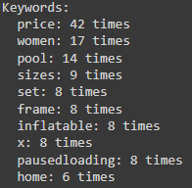

**Figure 1 - SEO Analysis (Keywords)**

Based on Figure 1, the most frequently occurring keywords, in order, are “price”, “women”, “pool”, “sizes”, “set”, “frame”, “inflatable”, “x”, “pausedloading”, and “home”. The frequency of these keywords may indicate that Walmart’s website heavily focuses on the price of their products and products that are related to women and pools at this current time period, which could indicate a promotion for these products occurring.

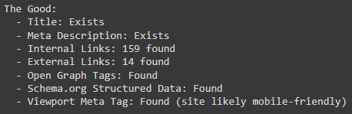

**Figure 2 - SEO Analysis (Strengths)**

Figure 2 identifies what Walmart’s website does well in terms of SEO. First of all, it has a title tag and meta description. These components are crucial in SEO as it gives a summary of their website, which will give users and search engines an idea of what their website is about.

Next, the website has 159 internal links and 14 external links. The internal links are beneficial as they enable better navigation of the website. In turn, it improves their SEO as search engines can find and index these pages to have a clearer understanding of the website. On the other hand, external links may be used to view external parties or partnerships.

Moving on, it can be seen that open graph and viewport meta tags were found, which essentially enhances how webpages are displayed. These tags are important as it allows Walmart to control how their website is displayed. Specifically, open graph tags control how their website is displayed in social media platforms (eg. Facebook, Twitter, and Instagram), while viewport meta tags control how their website is displayed on mobile.

Lastly, Schema.org structured data was found, which indicates that search engines may give enhanced search results.

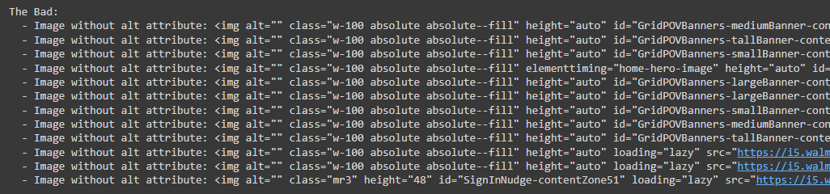

**Figure 3 - SEO Analysis (Weaknesses)**

Figure 3 identifies what Walmart’s website lacks in terms of SEO. In this case, the only thing they lack is alt text on a handful of images. Alt text is significant to SEO as it explains what a certain image is and explains how it relates to the webpage (Harvard University, n.d.).

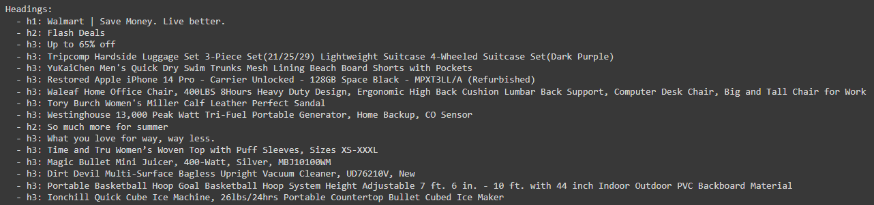

**Figure 4 - SEO Analysis (Headings)**

Figure 4 indicates that Walmart’s website has an acceptable form of heading hierarchy, h1 being the most important heading, while h4 being the more specific heading. For example, in Figure 4, h1 says “Walmart | Save Money. Live better.”, which is the website’s title, while h2 says “Flash Deals”, which is the main content that Walmart wants to convey to users. Having a well-structured heading hierarchy is important for SEO as it organizes their content in a logical way for users.

Overall, Walmart demonstrates a number of good SEO practices, specifically the use of a title and meta description, internal and external links, open graph and viewport meta tags, the use of Schema.org structured data, and the use of headings. However, Walmart has some room for improvement by including alt text in their images, as this text may be indexed by search engines, allowing for their content to appear more when users search their website. In terms of Best Buy, they can use Walmart’s SEO practices as a benchmark to improve their SEO.

## Interactivity and User Engagement

When running an eCommerce platform, it is important for users to have a positive experience to retain user engagement, and in turn, improve sales. To achieve this, information regarding the interactivity and user engagement of the website must be retrieved and analyzed. Similarly to the web metrics, this information was retrieved using SimilarWeb, specifically the total visits, device distribution, monthly visits, and pages per visit. Specifically, the metrics retrieved correspond with the performance of these websites from March 2024 to May 2024 (three-month period).

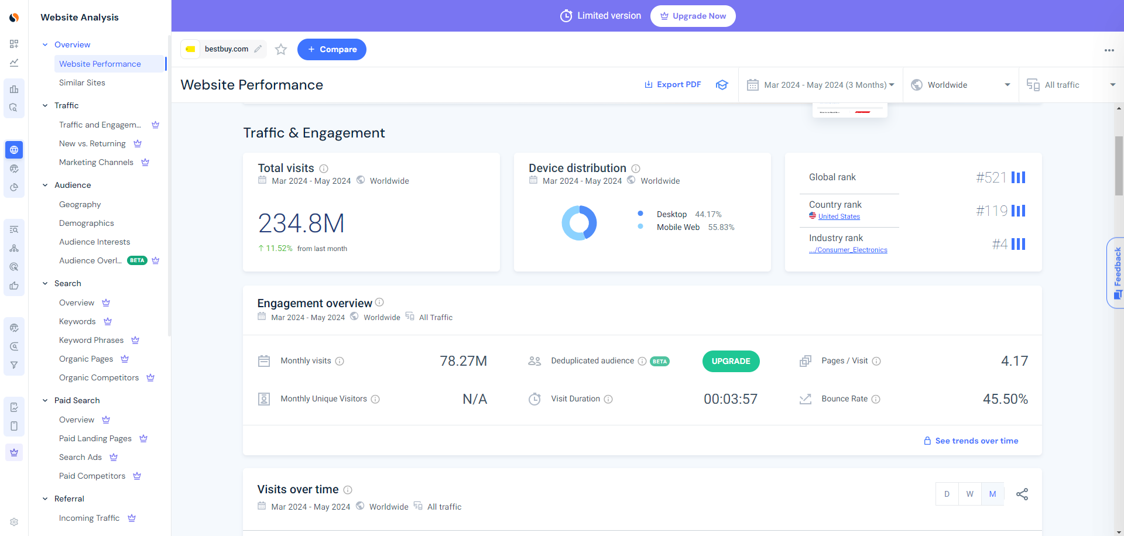

**Figure 5 - SimilarWeb (Best Buy)**

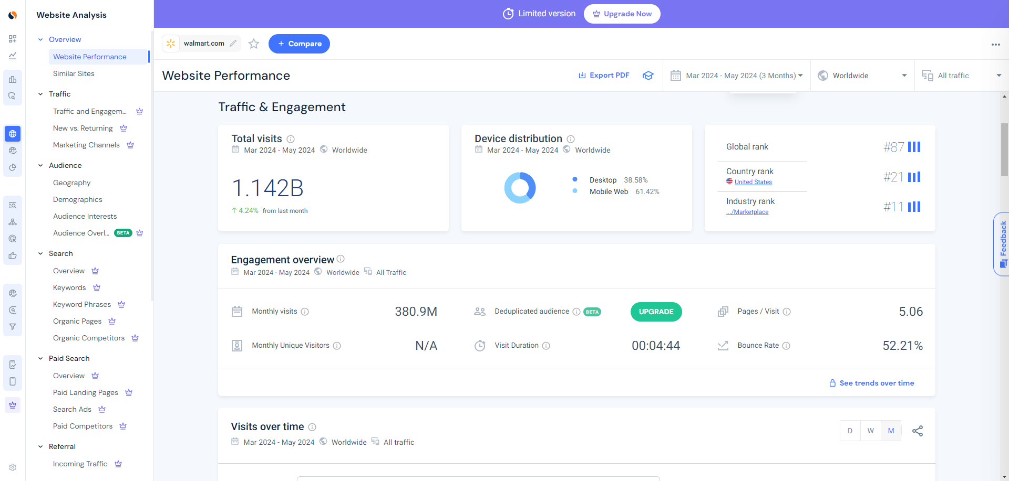

**Figure 6 - Similar Web (Walmart)**

Looking at the total visits, Best Buy has 234.8 million total visits and indicates a growth of 11.52% compared to the previous month. On the other hand, Walmart has 1.142 billion total visits and indicates a growth of 4.24% compared to the previous month. Comparing the two metrics, it is evident that Walmart’s total visits is significantly more than Best Buy’s by a wide margin. This wide margin is likely due to Walmart also catering to other target consumers as Walmart specializes in other departments unrelated to electronics.

Looking at the device distribution, 44.17% of Best Buy’s users were on desktop, while 55.83% of users were on mobile. Meanwhile, 38.58% of Walmart’s users were on desktop, while 61.42% of users were on mobile. This indicates that Best Buy has more users on desktop, while Walmart has more users on mobile.

Observing the monthly visits, Best Buy had 78.27 million average monthly visits, while Walmart had 380.9 million average visits. Comparing the two metrics, it is evident that Walmart has more average monthly visits, which directly correlates with their total visits. Similarly to the total visits, the wide margin in monthly visits could be due to Walmart specializing in other non-electronic departments.

Lastly, looking at the pages per visit metrics, the average pages per visit on Best Buy is 4.17, while the average pages per visit on Walmart is 5.06. Ideally, a smaller number of pages per visit is favorable as it indicates that users have to spend less time to find what they are looking for. For that reason, Best Buy outperforms Walmart as their average pages per visit is less than Walmart’s, meaning that the majority of users can easily obtain what they need faster and more efficiently.

Based on these findings, it can be concluded that Best Buy’s interactivity and user engagement is satisfactory as they are constantly improving, as demonstrated by their monthly growth. Their device distribution is distributed fairly well since the percentage of desktop users is close to their mobile users, which could indicate that the user experience on desktop and mobile are both positive. Lastly, their average pages per visit metric indicates that users are able to find what they are looking for in a short number of time/clicks. Although their average pages per visit metric outperforms Walmart, further optimization of their website could lower it more, indicating an even better user experience.

## Mobile Optimization

As an eCommerce platform, along with the desktop experience, it is also important for Best Buy to allocate resources into improving the mobile experience. Best Buy has both a mobile-responsive website, along with a dedicated app on the App Store and Google Play Store. It is important for Best Buy to optimize the mobile experience as mobile users make up a large demographic of consumers, as mentioned earlier (55.83%). Furthermore, it is objectively easier to access a mobile device compared to a desktop due to its convenience and accessibility.

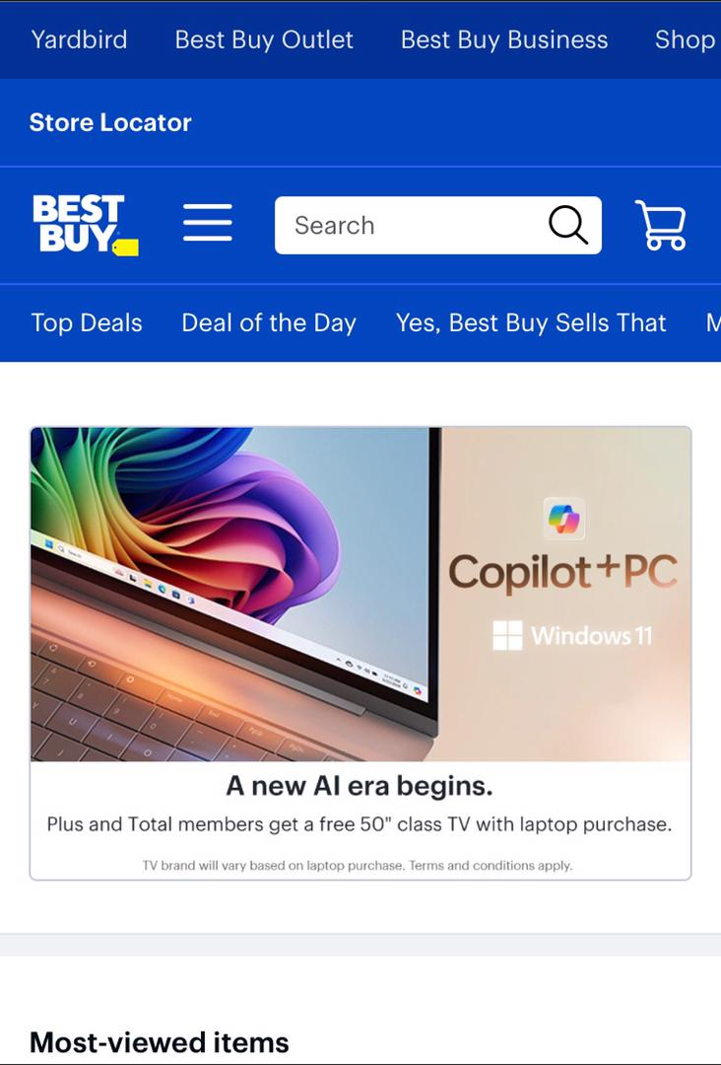

**Figure 7 - Best Buy Mobile Website (IOS)**

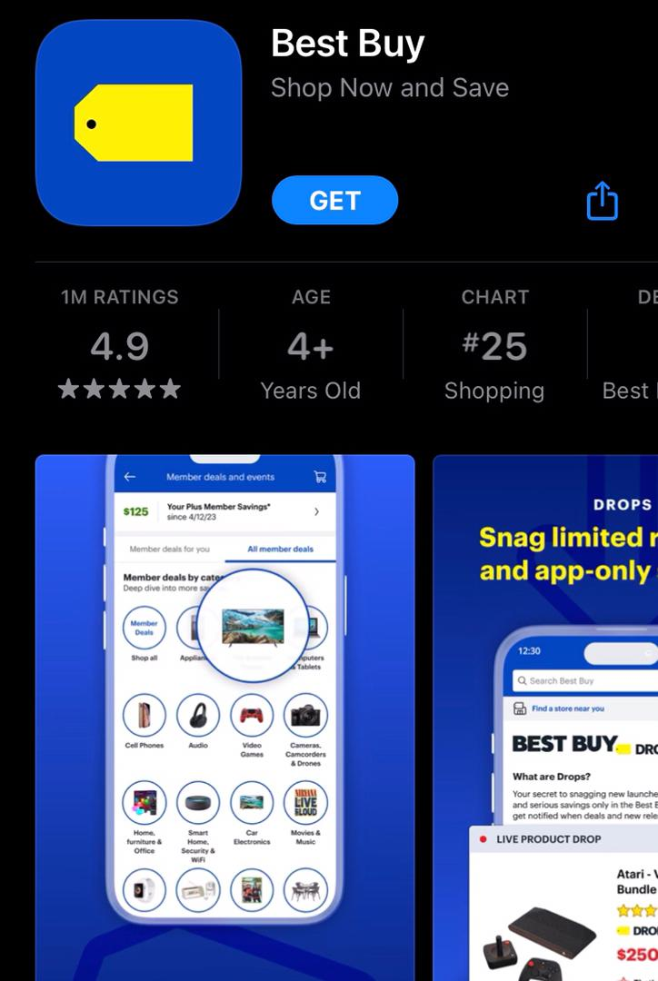

**Figure 8 - Best Buy Application (App Store)**

Similar to the web metrics for desktop, the same method of retrieving the web metrics for mobile was used. However, the bounce rate and session duration for mobile were unable to be retrieved as SimilarWeb only provides these metrics for the desktop website. The table below contains the web metrics retrieved from Google Lighthouse for Best Buy and Walmart, specifically their mobile metrics.

**Table 2 - Web Metrics (Mobile)**

|  |  |  |
| --- | --- | --- |
| **Web Metrics** | **Best Buy** | **Walmart** |
| Performance Score | 31.0 | 27.0 |
| First Contentful Paint | 3.3s | 4.3s |
| Speed Index | 9.1s | 14.9s |
| Time to Interactive | 36.8s | 41.3s |
| Bounce Rate | N/A | N/A |
| Session Duration (mm:ss) | N/A | N/A |

Observing the performance score, Best Buy’s mobile website has a performance score of 31, while Walmart’s mobile website has a performance score of 27. From these metrics, it is evident that both these websites are not performing well on mobile, however Best Buy slightly outperforms Walmart’s mobile website.

Looking at the FCP metric, Best Buy’s mobile website has an FCP of 3.3s, while Walmart’s mobile website has an FCP of 4.3s, indicating that the time it takes for Best Buy’s mobile website to load its content is faster than Walmart’s mobile website.

Looking at the Speed Index metric, Best Buy’s mobile website has a speed index of 9.1s, while Walmart’s mobile website has a speed index of 14.9s, indicating that Best Buy’s content appears faster on their mobile website compared to Walmart’s mobile website.

Lastly, observing the TTI metrics, Best Buy’s mobile website has a TTI of 36.8s, while Walmart’s website has a TTI of 41.3s, indicating that Best Buy’s mobile page becomes fully interactive faster than Walmart’s mobile website.

Based on these results, Best Buy’s mobile website outperforms Walmart’s mobile website in every metric. However, both of their overall performances are relatively poor. This is likely due to the technological constraints that mobile devices possess, as desktops have significantly more powerful hardware compared to mobile. As technology continues to advance within the mobile industry, Best Buy should capitalize and optimize their mobile website to enhance the experience for mobile users in the future.

# Data Preparation

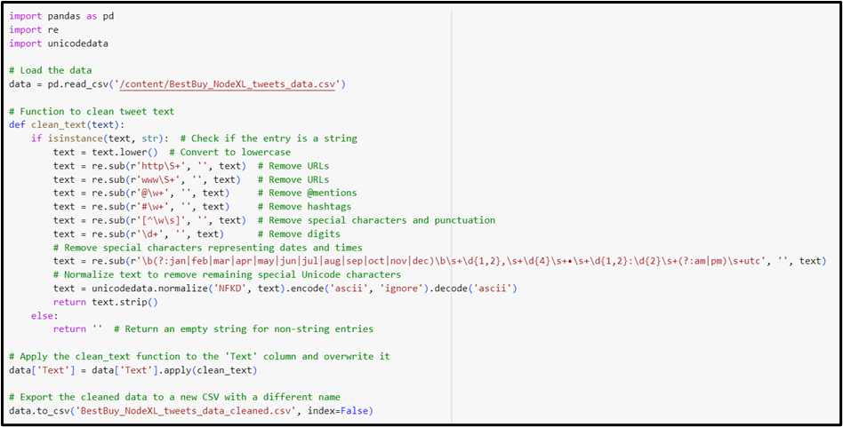

**Figure 8 - Data Cleaning Code**

To conduct data preparation, there is an array of processes that need to be done to ensure the integrity and usability of the data. Using Python in Google Colab, the necessary libraries are installed, such as ‘pandas’ for data manipulation and ‘ntscrapper’ for accessing the Twitter API. After installation, the next steps are to obtain access to Twitter’s API, in this case, Best Buy’s Twitter account is used for data analysis.

Once authenticated, the tweets can be scraped using ‘ntscrapper’, where 868 tweets were retrieved. The data is stored in a structured format using the Pandas DataFrame which captures relevant fields such as tweet text, user details, like, and retweets.

The next phase is to clean the data by removing the “noise”, which includes emojis, hashtags, special characters, digits and normalizing Unicode characters. This ensures that the text data is uniformed and free from extraneous elements that could skew analysis (Anderson et al., n.d.).

After cleaning, the data was saved into a new CSV file, and it is ready to be used for the study. For this study, the analyses that were conducted were Sentiment Analysis (using Text Blob, VADER, and Azure Machine Learning) and Social Network Analysis (using NodeXL). These analyses provide deeper insight into social media trends and public sentiment (Anderson et al., n.d.).

# Sentiment Analysis

The purpose of this sentiment analysis is to evaluate public opinions on Best Buy using their social media data. This analysis aims to categorize these posts into positive, neutral, and negative sentiments. The sentiment analysis results are presented in the form of a table, quantitatively indicating the frequency of each sentiment category.

**Table 3 - Sentiment Analysis (TextBlob, VADER, Azure ML)**

|  |  |  |  |
| --- | --- | --- | --- |
| Sentiment | TextBlob | VADER | Azure ML |
| Positive | 557 (64%) | 566 (65%) | 699 (81%) |
| Negative | 94 (11%) | 85 (10%) | 76 (9%) |
| Neutral | 217 (25%) | 217 (25%) | 93 (11%) |

Based on Table 3, it is clear that TextBlob and VADER generally have similar numbers, but Azure Machine Learning have a slightly different manner. Overall, all tools reveal that over half of the social media posts reflect a positive sentiment towards Best Buy which suggests that Best Buy is generally favored by the public. A large number of neutral posts show that many users feel balanced or indifferent. The lower percentage of negative posts indicates that while there are some negative opinions, they are not the majority. This suggests that most users either have positive or neutral views on the topics being discussed.

Looking into TextBlob, this tool uses a combination of rule-based approaches and machine learning to determine sentiment of the text. TextBlob's balanced sentiment distribution results from its reliance on a predefined lexicon and pattern analysis. VADER is optimized for social media texts using a sentiment lexicon and heuristic rules. VADER's slight increase in positive sentiments is due to its ability to handle informal language such as slang which is common in tweets. On the other hand, Azure ML uses advanced machine learning algorithms trained on large datasets. Azure ML's higher positive sentiment detection may be due to its complex models which might overestimate positivity of promotional and customer service-oriented language which are common in Best Buy tweets.

There are a few reasons why the three tools yield different results, which starts from the approaches of the tools. TextBlob and VADER rely on predefined dictionaries which are also known as lexicons and set rules to analyze sentiment. This approach makes them more conservative because they only recognize sentiments explicitly listed in their dictionaries. Therefore, they might miss nuanced expressions or new slang. However, Azure Machine Learning uses advanced machine learning algorithms trained on extensive datasets. These models can pick up subtle sentiment cues, but they might also overestimate positivity due to biases in the training data. For instance, if the training data had more positive reviews, the model might lean towards positive classifications. Besides that, text handling of different tools also comes in, where VADER, which is designed specifically for social media, can better interpret the informal language, abbreviations, and emoticons common in tweets. This makes it more accurate in understanding the casual tone often found on platforms like Twitter. Azure Machine Learning uses general models that may not be as finely tuned for social media nuances, leading to a possible skew towards positive sentiments if the language used is promotional or supportive. Each tool has its own way of interpreting the context of words and phrases. Machine learning models like Azure ML can recognize subtleties and context that rule-based systems like TextBlob and VADER might miss. For example, sarcasm or irony can be challenging for lexicon-based tools to detect, but a well-trained machine learning model might catch these nuances.

# Data Visualization

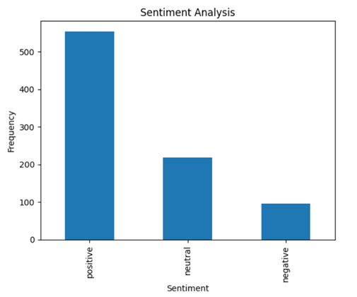

**Figure 9 - Sentiment Analysis Visualization (TextBlob)**

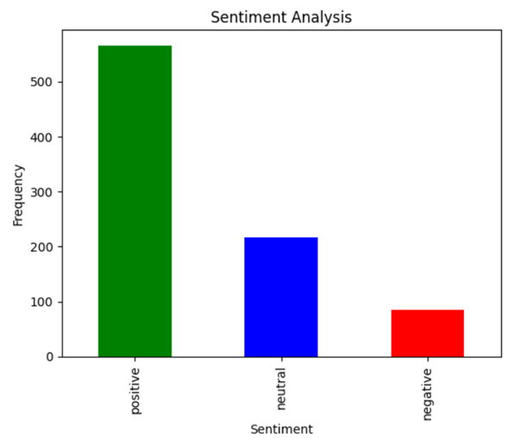

**Figure 10 - Sentiment Analysis Visualization (VADER)**

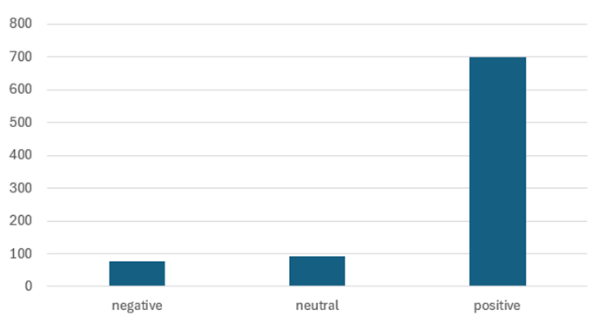

**Figure 11 - Sentiment Analysis Visualization (Azure ML)**

Using the data retrieved earlier on, three types of tools are used to undergo sentiment analysis visualization which are TextBlob, VADER and Azure Machine Learning. Figures 9 and 10 are bar charts output by TextBlob and Vader, which shows a predominant positive sentiment among the analyzed posts, while neutral sentiments form a huge portion, and negative sentiments are the least frequent. Figure 11 is a bar chart output by Azure ML, which shows a predominantly positive sentiment. Looking at the neutral sentiment, it is relatively infrequent compared to the positive sentiment, however negative sentiments slightly occur less frequently than negative sentiments.

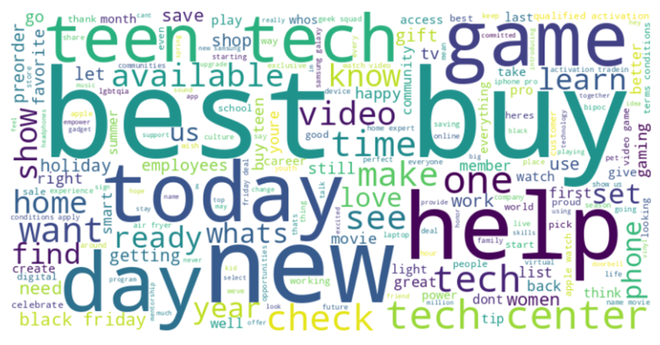

**Figure 12 - Word Cloud (TextBlob)**

The word cloud from Best Buy's tweets displays the key themes and strategies in their social media communication. "Best" and "Buy" are the most dominant words, highlighting a strong focus on brand visibility and reinforcement. "Today" emphasizes urgency, suggesting a strategy centered around current deals and promotions. "New" directs focus on new product launches, attracting customers interested in the latest technology. "Help" indicates a commitment to customer service, using Twitter as a platform for assistance. "Check", "Find”, and "Use" are action words encouraging customers to explore and engage with Best Buy’s offerings. "Tech", "Game", "Phone", and "Video" display the types of products being promoted, aligning with their niche in electronics and gaming. "Teen" suggests a focus on younger audiences, tailoring promotions to appeal to teenagers and young adults. "Deal", "Sale", "Black Friday", and "Gift" all highlight the emphasis on promotional events and sales, especially around significant shopping periods. "Holiday", "Summer", and "Year" indicate that Best Buy tailors its marketing strategies to align with seasonal trends and customer buying cycle. Words like "community" and "empower" suggest efforts to build a community around the brand and empower customers with knowledge about the latest tech.

# Social Network Analysis

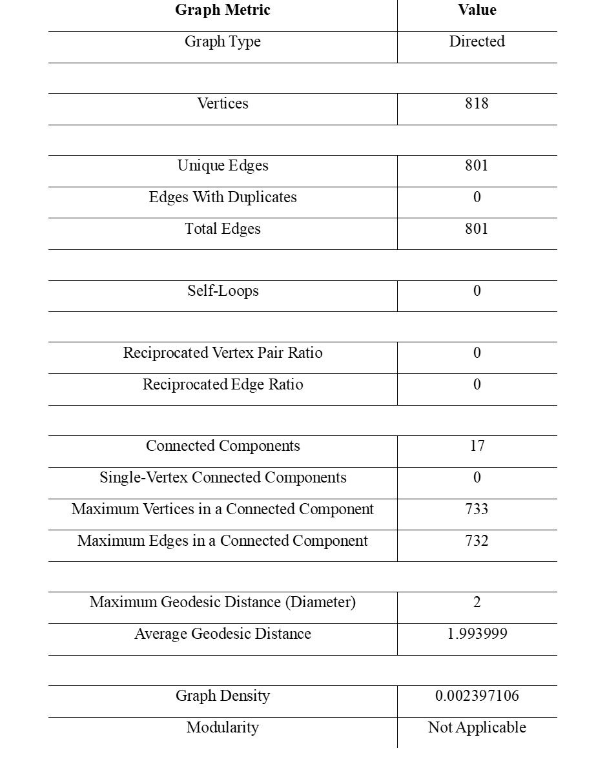

**Figure 13 - Graph Metrics**

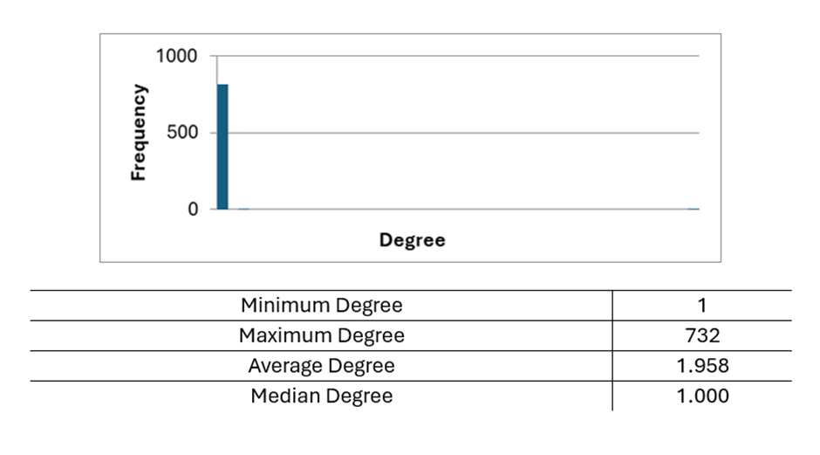

**Figure 14 - Degree (NodeXL)**

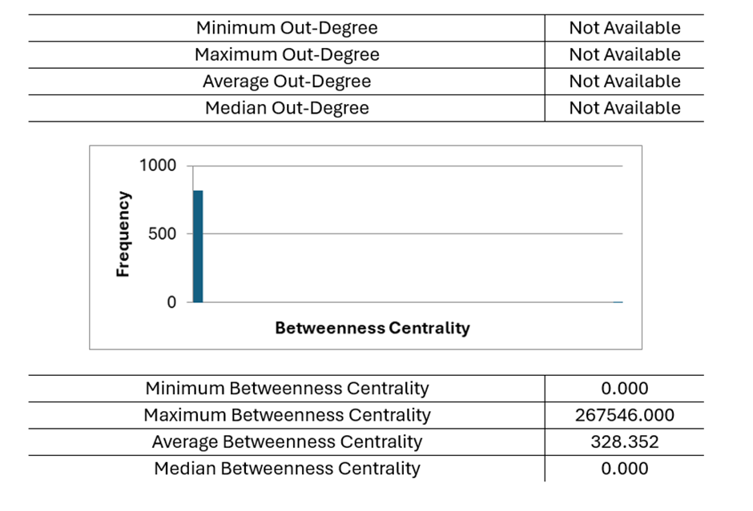

**Figure 15 - Centrality 1 (NodeXL)**

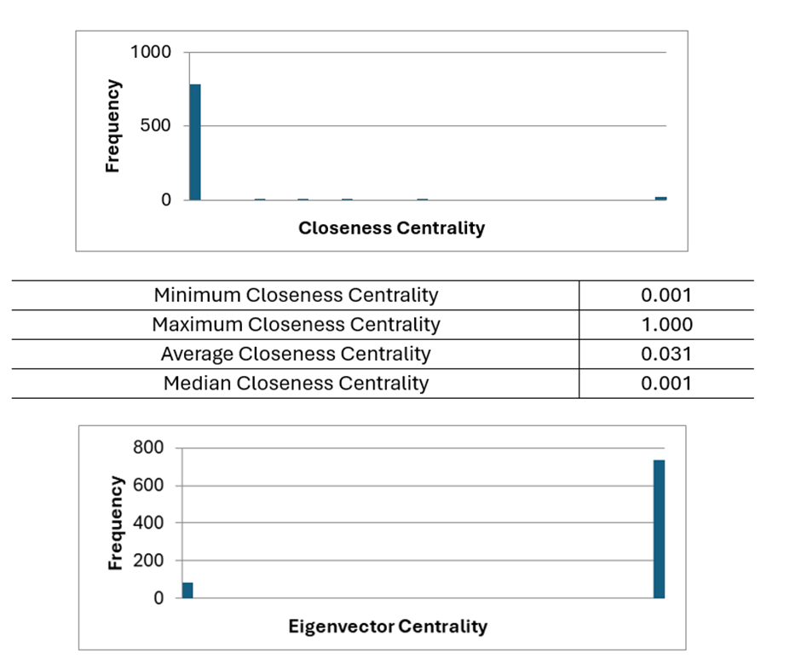

**Figure 16 - Centrality 2 (NodeXL)**

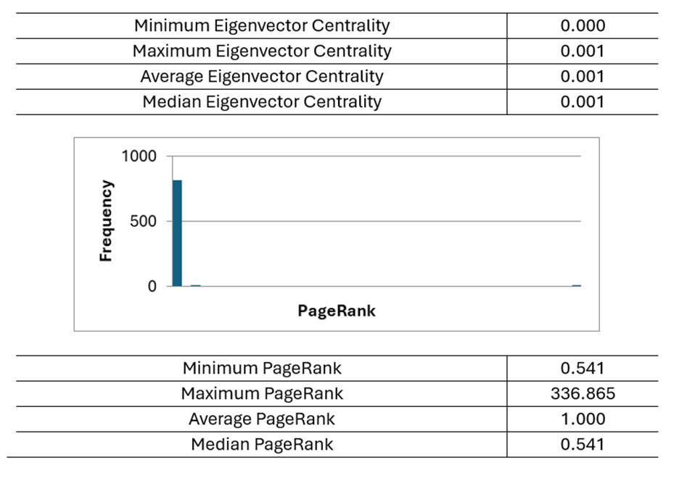

**Figure 17 - Page Rank (NodeXL)**

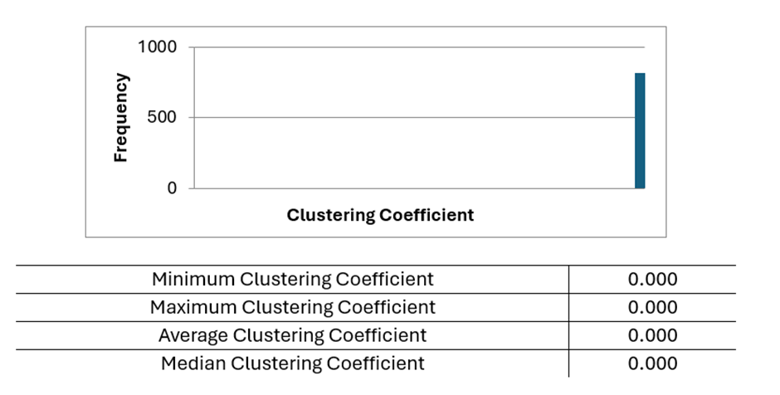

**Figure 18 - Clustering Coefficient (NodeXL)**

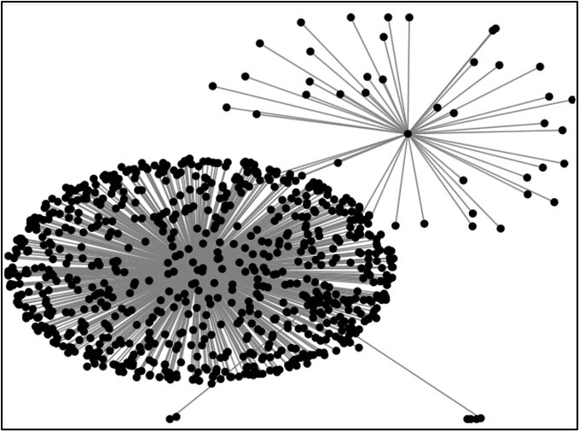

**Figure 19 - Graph metrics for Best Buy’s Twitter datasets (NodeXL)**

In this analysis, NodeXL is used to build a directed graph from the dataset. In this analysis, the things that were measured included centrality measures, such as betweenness centrality, closeness centrality, eigenvector centrality and page rank. These measurements were calculated to identify influential users and key interactions patterns. This analysis also shows the general graph metrics that are important in understanding the overview of the datasets. Any duplicates in the datasets for this analysis have been removed.

The graph type used for this dataset is undirected which indicates that the connections between them are mutual. In other words, if user A interacts with user B, it can also be considered that user B interacts with user A. There are 818 unique users who have interacted with Best Buy’s tweets or part of the analyzed Twitter network. Each interaction is unique as no duplicate interactions were found. Total edge is the same as the unique edge with no duplicate interactions.

In terms of connectivity, the network was divided into 17 separate sub-networks or clusters which indicates that there are 17 groups of users who are connected among themselves but not with users in other groups. There are no isolated users as every user was connected to at least one other user in the network. The maximum vertices in a connected component were 733 users which indicates a significant portion of the users are part of one large interaction group. On the other hand, the maximum edge in a connected component was 732, indicating active engagement among the users within the cluster.

The maximum geodesic distance (Diameter) was 2, meaning that the longest and the shortest path between any two users in the network is 2 steps. It indicates any user can reach any other user within two interactions. Meanwhile, the average geodesic distance was 1.993999 which on average any user can reach another user in just under 2 interactions. This analysis suggests a small-world phenomenon where users are closely connected.

However, the graph density is very low indicating that only a small number of the possible connections between users were present. This shows that while users interact, they do so sparsely.

For the graphs that were shown above, different types of graphs interpret different analyses that provide useful information for social media analytics. For degree metrics, the minimum degree is 1 which shows that each user has at least one connection. The maximum degree is 732 indicates that one user is extremely well connected, with interactions from 732 different users. The average degree is 1.958 which shows that each user interacts with nearly 2 other users whereas the median degree is 1.000 indicating that half of the users have only one interaction. This shows that there is a skewed distribution with a few highly connected users.

For centrality metrics, in terms of betweenness centrality, the graph shows that while most users do not act as bridges between other users, there are a few users that play a crucial role in connecting different parts of the networks. This interaction could be key influencers or highly active users who amplify messages.

The closeness centrality indicates that on average users are not very central in the network. However, there are a few exceptions who are very central and can reach other users easily. In eigenvector centrality, all users have shown a very low number which indicates that no single user is significantly influential based on their connections to other highly connected users. Page rank reflects a significant disparity in user influence. This shows that some users have a much higher likelihood of spreading information throughout the network.

In terms of clustering coefficient, all graphs i.e. minimum, maximum, average and median do not show any values indicating no formation of tight-knit groups or local clusters. This can be concluded that users do not form any small, densely connected groups within the network.

The analysis was also tested before doing any duplication to see if there is any difference between both. The results for graphs and metrics were presented at the appendix for reference. In this context, particularly the datasets that were used, the duplicates do not materially affect the overall analysis of the datasets. The key insights and patterns related to user engagement, network structure and temporal trends remained consistent regardless of the presence of duplicate retweets.

# Discussion

## Themes Identification & Demographic Insight

There are some themes that have been identified in the Best Buy’s Tweet. Firstly, the discussion about general technology and assistance is noticeable. Users frequently tweet about tech products, seeking help or sharing information about their experiences. This shows a strong community of users relying on each other for tech-related guidance.

Next, home tech and gaming content is a significant theme. Users often share their experience about the gaming setup, home entertainment system and the latest tech gadgets for the household. This highlights Best Buy’s role as a go-to place for tech savvy looking to upgrade their home environment.

Some users also discuss Apple product promotions, especially iPhone. The tweets discuss new releases, trade-in deals and the latest Apple gadget. This shows Best Buy is one of the hubs where people are interested in buying Apple products from them.

Lastly, new TV releases and Samsung Galaxy products are common topics where users discuss the latest televisions and Samsung devices. This shows the brand’s strength in the consumer electronic market.

While the dataset lacks demographic information, there are some hypotheses that can be made through the observation from the tweets. Users that frequently engage in Best Buy’s tweets are predominantly male who are in their youth i.e. below 40 years old. They are tech savvy as their conversation is about the latest technology that is available on the market. Some of the users are also game savvy as they are interested in the new game console.

This shows the presence of users in Best Buy’s tweets that are mostly people interested in electrical appliances. By understanding the demography of the users, Best Buy could refine its marketing strategies, enhance customer service and foster community engagement, hence driving better business outcomes.

## Sentiment Connotation

The sentiment analysis on 868 tweets from Bust Buy’s Twitter account examines public opinion using TextBlob, VADER and Azure Machine Learning. This is done to categorize the sentiments into positive negatives or neutral. Results show a very strong positive statement: Azure ML detected 81% positive, VADER 65% and TextBlob 64%. Neutral sentiments were significant, with TextBlob and VADER are 25% whereas Azure ML at 11%. Negative statements show the least results with TextBlob at 11%, VADER at 10% and Azure ML at 9%.

These three methods show different results as they are using a different way to process the Tweets. TextBlob and Vader rely on predefined lexicons which make them more conservative but could have the potential to miss nuances (Wankhade et al., 2022). However, VADER is optimized for social media as it can handle slang and informal language better. Meanwhile, Azure ML uses advanced machine learning, which is very good at capturing subtle cues, but it could overestimate positivity in promotional language (Hussein, 2018).

The word cloud from Best Buy’s tweets highlights key themes: “Best” and “Buy” which emphasize brand awareness among the users. The words “Today” and “New” focus on promotions while “Help” indicates customer service. As Best Buy is synonymous with selling electronic appliances, the words “Game” and “Phone” are frequently being used in the tweets. The words “Deal” and “Sale’ emphasize promotional events.

This analysis shows that Best Buy is commonly well-regarded as the tweets portrayed effective customer engagement and satisfaction, reflected in the high number of positive and neutral sentiments.

## Social Network Analysis

In the social network analysis, Best Buy’s Twitter interactions possess a sparse network which can be identified by limited connections between users. The engagement between the users was very minimal, which can be interpreted as a casual interaction rather than robust community building. This type of engagement needs to be improved and one way to fix it is by creating buzz (Vinerean et al., 2013). Best Buy could Tweet something that needs users to interact with them such as creating hashtags, doing challenges or creating polls.

Within this network, there are a few users that stand out as highly influential. In disseminating information, these key nodes, with high degree and betweenness centrality scores will play an important role (Warokka, 2020). Best Buy should target these users or influencers for marketing initiatives as it can help to significantly amplify their message reach.

A large, connected component within the network indicates a potential focal point for engagement strategies. Best Buy could put efforts into this group as it can help to maximize reach and impact. Simultaneously, a more cohesive and supportive community could be achieved by integrating a smaller component into the main network.

Low average geodesic distance shows the network’s small-world nature presence in the datasets. It indicates that messages can propagate swiftly despite the overall sparse engagement. For Best Buy, it could be advantageous for them as this rapid spread is crucial for timely promotions and updates. However, it still needs to strategize their approach to enhance overall engagement.

By doing this analysis, it could help Best Buy to implement more suitable campaigns or activities that could improve connectivity and encourage users to interact. By promoting more frequent engagement and fostering a sense of community, the network’s density can increase, creating a more robust and stronger cluster of engaged users (Saravanakumar & Suganthalakshmi, 2012). In short, while Best Buy’s Twitter has some influential users, there is a significant potential to enhance overall engagement and create a more interconnected community.

# Future Recommendations

After analyzing the tweets from Best Buy, there are some ideas to further improve the digital advertising strategy of Best Buy. Firstly, it is crucial to emphasize timely promotions. Keywords like "today," "new," and "deal" should be prominently featured in digital ads to create a sense of urgency. Customers are attracted to immediate offers and new products, as highlighted in the word clouds. By leveraging these keywords, Best Buy can encourage quick customer actions and drive sales.

Another effective strategy is leveraging Best Buy's strong brand recognition. By prominently featuring the "Best Buy" name in advertisements, the company can capitalize on the brand loyalty evident from customer interactions. The frequent mention of the brand name in customer tweets suggests a strong affinity, which can be reinforced through strategic advertising efforts.

Enhancing customer support is also vital. Promoting customer service capabilities by highlighting terms like "help" and "assist" in ads can differentiate Best Buy from competitors. The frequent use of these words indicates that customers value assistance highly, suggesting that emphasizing these services in marketing efforts can positively impact customer perception and satisfaction.

Targeting younger demographics is essential for future growth. Campaigns aimed at teens and young adults, focusing on relevant products and services, can effectively capture their interest. The presence of the term "teen" in the word cloud indicates a huge portion of Best Buy's audience is young, making it crucial to tailor marketing efforts to this group.

Focusing on high-interest product categories such as "tech," "game," and "phone" in ad content can drive increased engagement. These terms are heavily mentioned, suggesting significant consumer interest. By promoting these product categories, Best Buy can align their marketing strategies with customer preferences and boost engagement and sales.

Promoting sales events by strategically timing ads around major shopping periods like Black Friday, using terms such as "sale," "deal," and "gift," can also boost traffic and sales. The word cloud reveals that promotional events are key drivers of customer engagement. Aligning ad campaigns with these events can maximize their impact and drive more traffic to the website.

Encouraging community engagement is another effective strategy. Fostering a sense of belonging and customer empowerment in ads can enhance customer loyalty. Words like "community" and "empower" indicate that customers value being part of an informed and supportive community, which can be emphasized in marketing efforts to build stronger customer relationships.

In addition to these primary strategies, several other recommendations can further enhance digital advertising efforts. Personalized marketing, using data analytics to tailor ads to individual preferences and past behaviors, can significantly improve engagement and conversion rates. Developing engaging video content displaying product features, reviews, and tutorials can effectively demonstrate product benefits, as video content is highly engaging.

Partnering with tech influencers and gaming personalities can also extend reach and add credibility to promotions. Creating interactive ads, such as quizzes and polls, can increase user engagement and time spent with the brand. Highlighting customer testimonials in ads can enhance trust and encourage purchases, leveraging the power of social proof. By focusing on users with high centrality and page rank and those occupying critical network positions, Best Buy can effectively amplify its messages. Collaborating with these influencers for promotional content and product announcements can significantly increase reach and impact. These influencers act as bridges within the network, ensuring that information spreads widely and quickly.

Implementing retargeting campaigns for visitors who have previously engaged with the website or products can remind customers of their interests and encourage them to complete their purchases. Segmented email marketing campaigns promoting new arrivals, sales events, and exclusive offers can reach customers with personalized content, while increasing social media engagement through contests, giveaways, and interactive posts can boost brand loyalty and awareness.

Optimizing ads for mobile devices ensures a seamless experience for users on smartphones and tablets, crucial as many consumers browse and shop on mobile devices. Lastly, continuously analyzing ad performance data to refine and optimize campaigns ensures that advertising efforts are efficient and effective, maximizing return on investment. By implementing these strategies, Best Buy can enhance its e-commerce operations, improve customer engagement, and drive sales growth.

# Conclusion

In conclusion, based on web analytics landscape analysis, sentiment analysis, and social network analysis, Best Buy’s performance is satisfactory but has room for improvements. Looking into their web analytics landscape, the key finding is that they have desirable web metrics within their industry. In terms of their SEO and visibility, Best Buy could learn from Walmart as they perform a number of good SEO practices that enhance their visibility on search engines. However, Best Buy can learn from Walmart’s mistakes by including alt text in their images. Looking at Best Buy’s interactivity and user engagement, they are in a good spot as their total visits are constantly growing as time goes on. Lastly, Best Buy’s mobile website is relatively adequate as it outperforms Walmart’s website. Moving on to sentiment analysis, it can be concluded that the majority of users have positive views on Best Buy. Furthermore, based on the word cloud, it can be concluded that the main demographic are younger people who are tech savvy. Finally, based on the findings from the social network analysis, it can be concluded that a small number of users have an influence within this network. This is important as these users play a crucial role when it comes to circulating information and connecting with different communities within the network.

# References

Adobe. (2023, January 19). *What is ecommerce bounce rate?* Retrieved June 10, 2024, from https://business.adobe.com/blog/basics/ecommerce-bounce-rate#:~:text=While%20it%20is%20good%20to,good%20benchmark%20range%20for%20ecommerce

Almukhtar, F., Mahmoodd, N., & Kareem, S. (2021). Search engine optimization: A review. Applied Computer Science, 17(1), 69–79. https://doi.org/10.23743/acs-2021-07

Anderson, M., Sims, J., Price, J., & Perspective, J. B. (n.d.). *Turning “Like” to “Buy” Social Media Emerges as a Commerce Channel*.

Google. (2023, May 30). *First Contentful Paint (FCP)*. web.dev. Retrieved June 10, 2024, from https://web.dev/articles/fcp

Google. (2023, May 30). *Time to Interactive (TTI)*. web.dev. Retrieved June 10, 2024, from https://web.dev/articles/tti

Google. (n.d.). *Performance scoring* | Chrome Developers. Retrieved June 10, 2024, from https://developer.chrome.com/docs/lighthouse/performance/performance-scoring#metric-scores

Google. (n.d.). *Speed index* | Chrome Developers. Retrieved June 10, 2024, from https://developer.chrome.com/docs/lighthouse/performance/speed-index

Harvard University. (n.d.). *Describe content and images*. Retrieved June 11, 2024, from https://accessibility.huit.harvard.edu/describe-content-images#:~:text=Alternative%20(Alt)%20Text%20is%20meant,example%20of%20a%20missing%20image

Hussein, D. M. E. D. M. (2018). A survey on sentiment analysis challenges. *Journal of King Saud University - Engineering Sciences*, *30*(4), 330–338. https://doi.org/10.1016/j.jksues.2016.04.002

Saravanakumar, M., & Suganthalakshmi, T. (2012). Social Media Marketing. In *Life Science Journal* (Vol. 9, Issue 4). http://www.lifesciencesite.comhttp://www.lifesciencesite.com.670

SimilarWeb. (2024). *Website performance overview: BestBuy.com*. SimilarWeb. Retrieved June 10, 2024, fromhttps://pro.similarweb.com/#/digitalsuite/websiteanalysis/overview/website-performance/*/999/3m?webSource=Total&key=bestbuy.com

SimilarWeb. (2024). *Website performance overview: Walmart.com*. SimilarWeb. Retrieved June 10, 2024, fromhttps://pro.similarweb.com/#/digitalsuite/websiteanalysis/overview/website-performance/*/999/3m?webSource=Total&key=walmart.com

Vinerean, S., Cetina, I., Dumitrescu, L., & Tichindelean, M. (2013). The Effects of Social Media Marketing on Online Consumer Behavior. *International Journal of Business and Management*, *8*(14). https://doi.org/10.5539/ijbm.v8n14p66

Wankhade, M., Rao, A. C. S., & Kulkarni, C. (2022). A survey on sentiment analysis methods, applications, and challenges. *Artificial Intelligence Review*, *55*(7), 5731–5780. https://doi.org/10.1007/s10462-022-10144-1

Warokka, A. (2020). Digital Marketing Support and Business Development Using Online Marketing Tools: An Experimental Analysis. *International Journal of Psychosocial Rehabilitation*, *24*(1), 1181–1188. https://doi.org/10.37200/ijpr/v24i1/pr200219

# Appendix

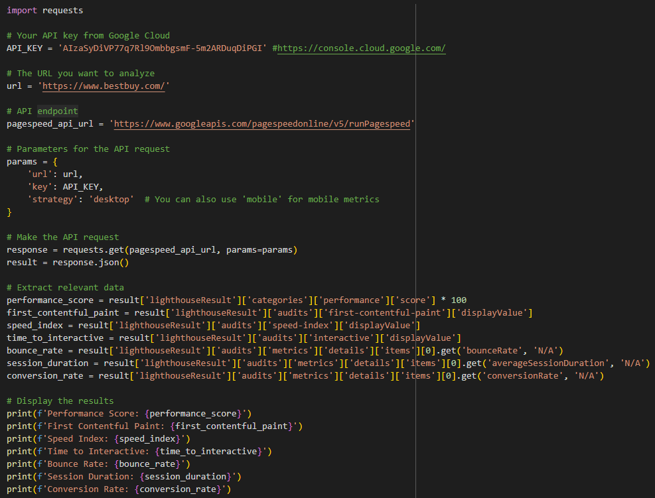

**Figure A1 - Lighthouse (Python)**

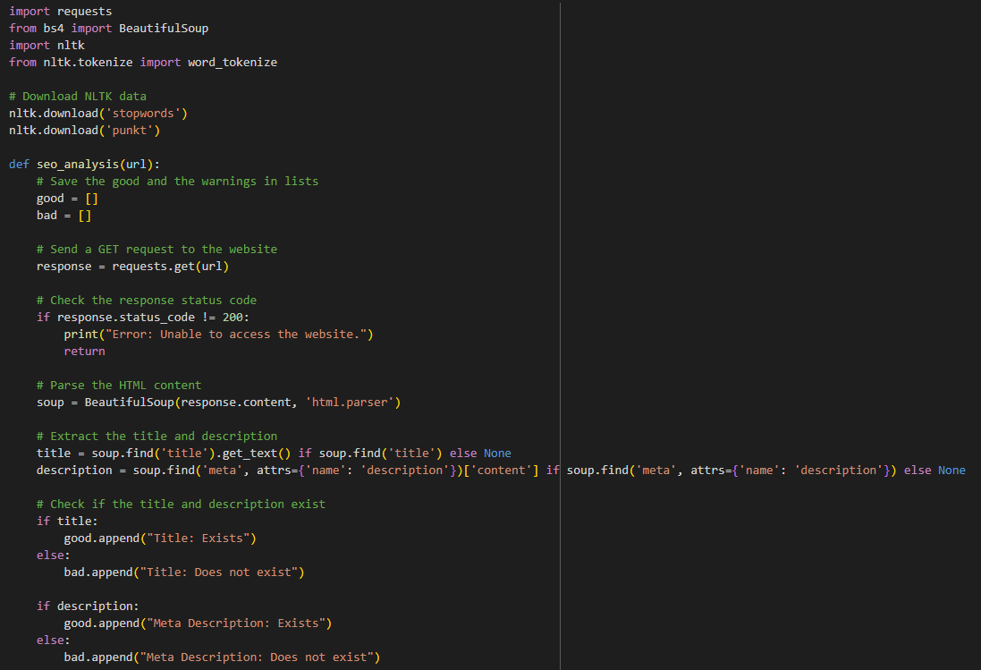

**Figure A2 - SEO Analysis 1 (Google Colab)**

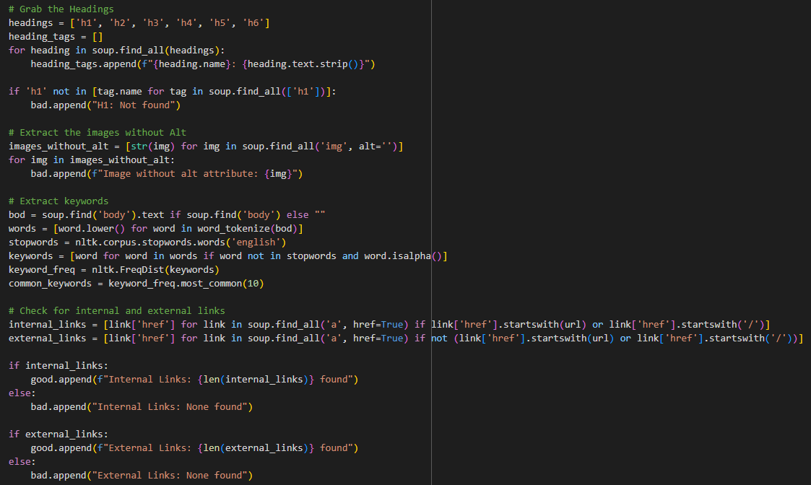

**Figure A3 - SEO Analysis 2 (Google Colab)**

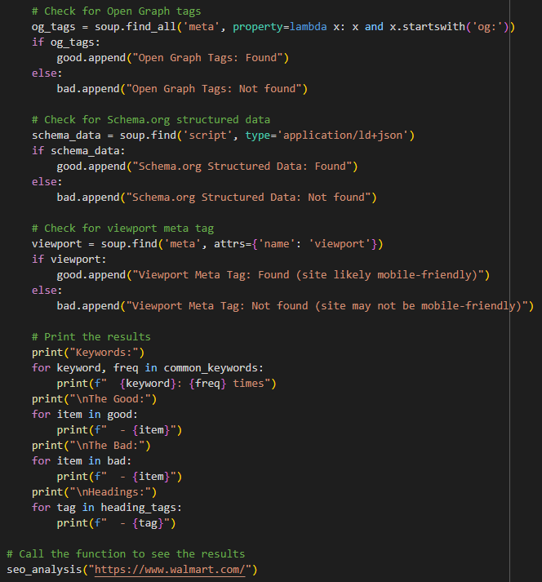

**Figure A4 - SEO Analysis 3 (Google Colab)**

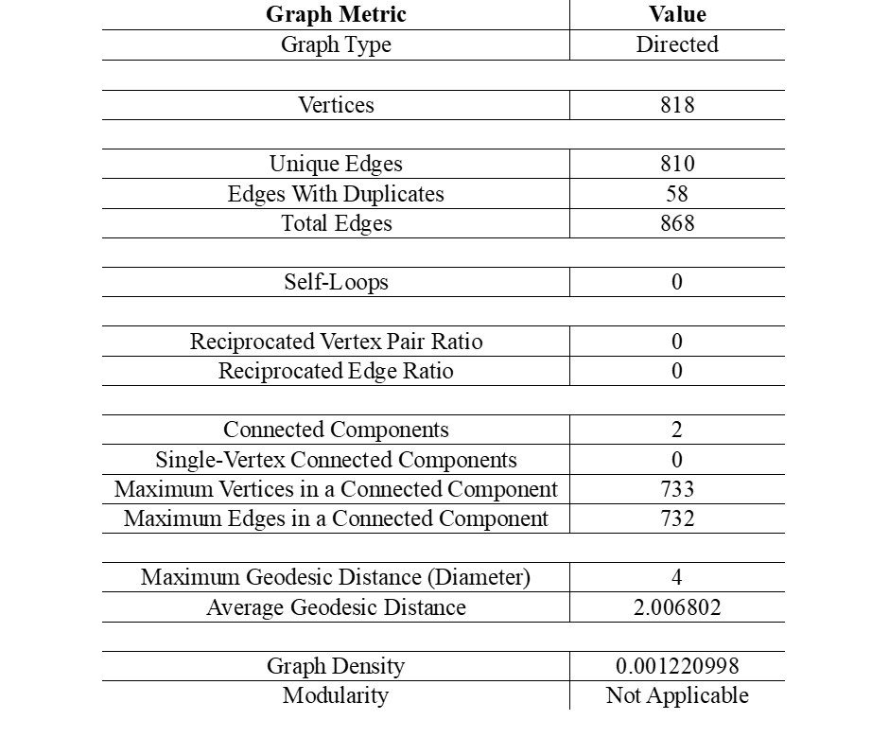

**Figure A5 - Social Network Analysis Before Duplicates 1**

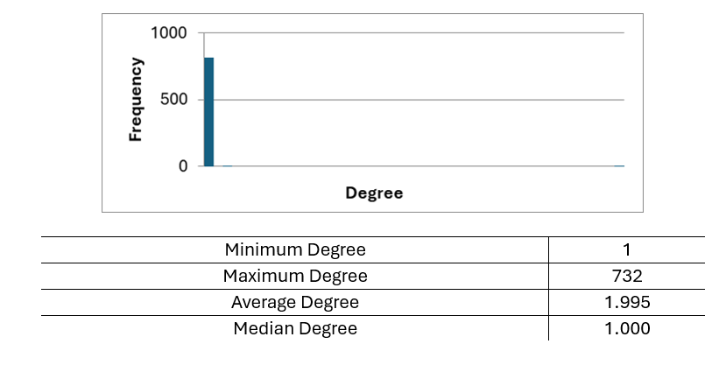

**Figure A6 - Social Network Analysis Before Duplicates 2**

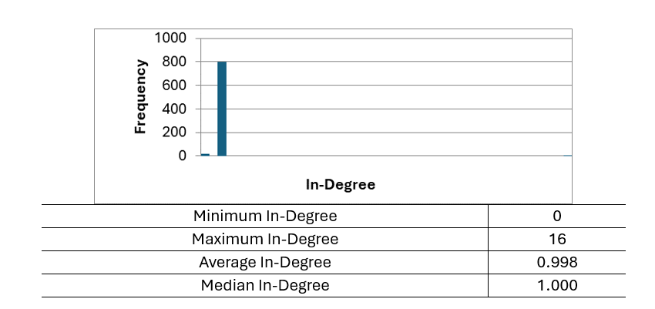

**Figure A7 - Social Network Analysis Before Duplicates 3**

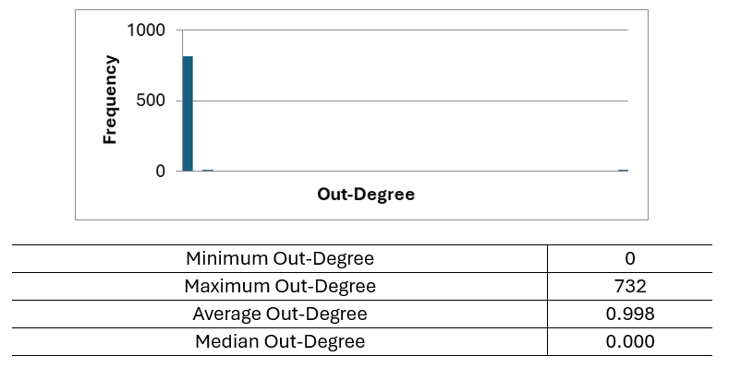

**Figure A8 - Social Network Analysis Before Duplicates 4**

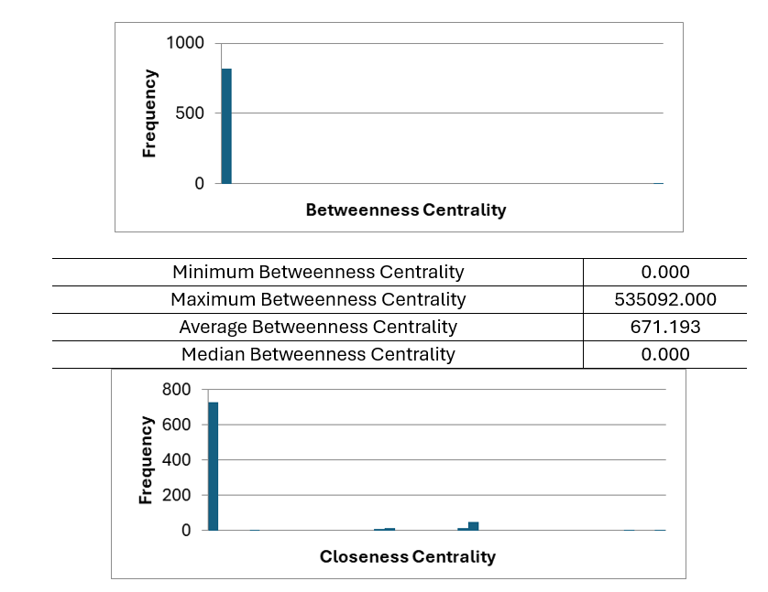

**Figure A9 - Social Network Analysis Before Duplicates 5**

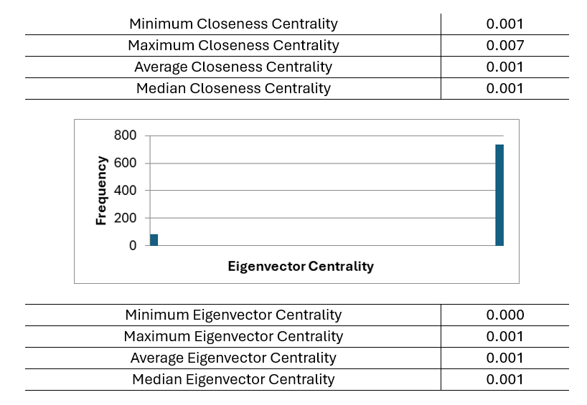

**Figure A10 - Social Network Analysis Before Duplicates 6**

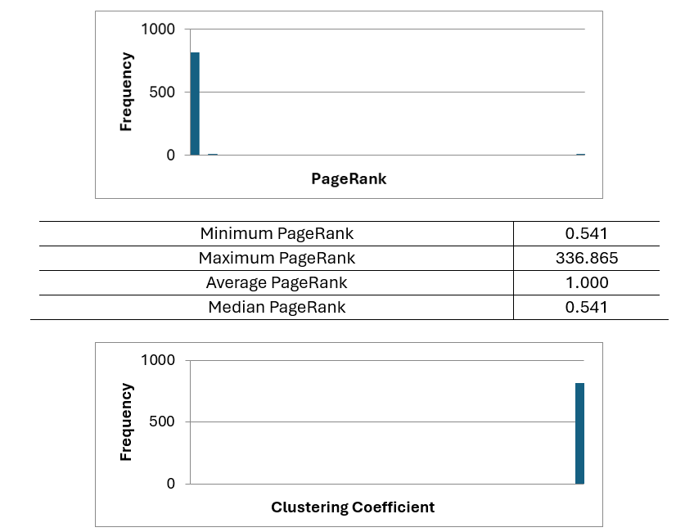

**Figure A11 - Social Network Analysis Before Duplicates 7**

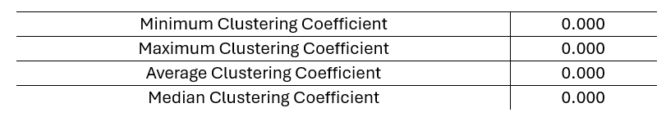

**Figure A12 - Social Network Analysis Before Duplicates 8**

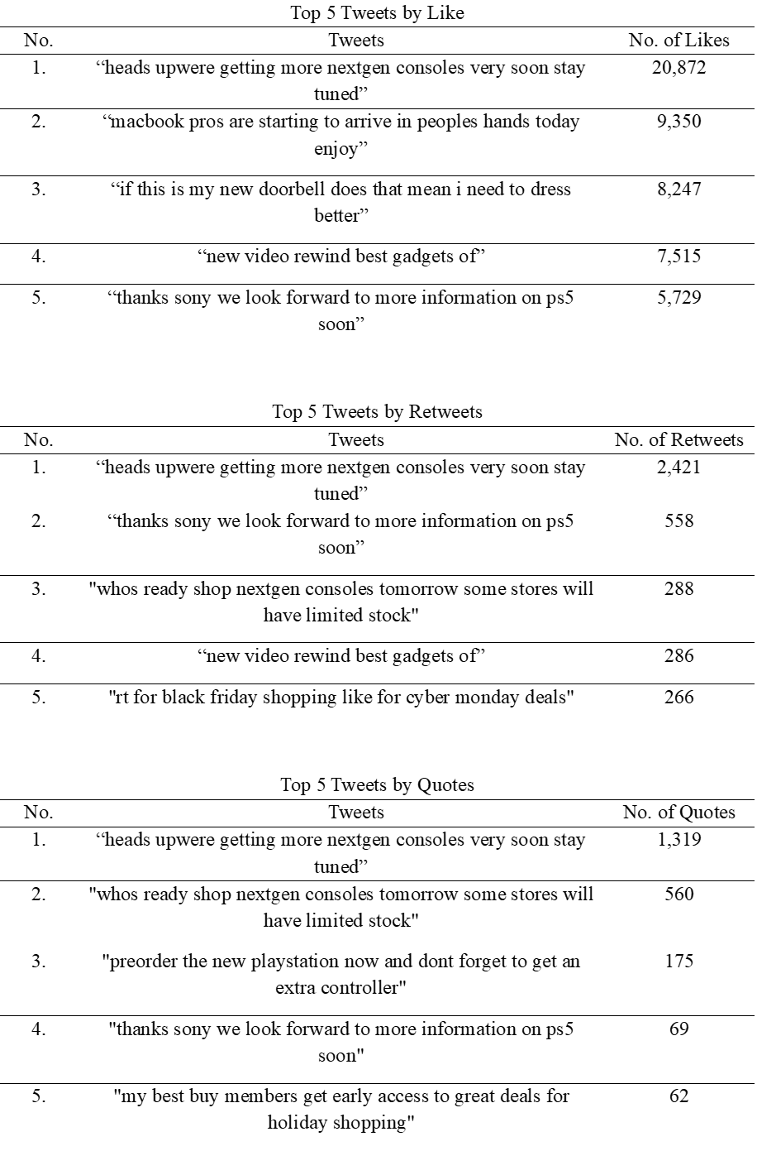

**Figure A13 - Engagement Analysis**